|  |  |
| --- | --- |
| **CL2001**  **Data Structures Lab**  [DS] | **Lab 09**  **Balance in Binary Search Trees, AVL Trees with all operations** |

**National University of Computer and Emerging Sciences**

**Fall 2025**

**Lab Content**

Balance in Binary Search Tree:

Approach:

Level Order Traversal Using Queue:

AVL Tree:

Example of AVL Tree:

Example of a Tree that is NOT an AVL Tree:

Why AVL Trees?

Rotations in AVL Trees:

Right Rotation (RR)

Left Rotation (LL)

Left-Right Rotation (LR)

Right-Left Rotation (RL)

Insertion in AVL Tree:

Illustration of Insertion at AVL Tree

Deletion in AVL Tree:

Searching in AVL Tree:

LAB TASKS

# **Balance in Binary Search Tree:**

A balanced binary tree is a type of tree in data structure used to keep data sorted and easy to search. In this tree, the left and right sides are kept at nearly the same height. This balance helps to make sure that no side of the tree is too deep, which can slow down data operations.

In a balanced binary tree, each node has up to two children. The tree is arranged so that the height difference between the left and right sides of any node is no more than one. This means the tree stays short and wide rather than tall and skinny, which helps in quick searching, adding, and removing of data.

|  |  |
| --- | --- |
|  |  |
| Unbalanced Binary Search Tree | Balanced Binary Search Tree |

## Approach:

The idea is to store the elements of the tree in an array using inorder traversal. Inorder traversal of a BST produces a sorted array. Once we have a sorted array, recursively construct a balanced BST by picking the middle element of the array as the root for each subtree.

Follow the steps below to solve the problem:

1. Traverse given BST in inorder and store result in an array. Note that this array would be sorted as inorder traversal of BST always produces sorted sequence.
2. Build a balanced BST from the above created sorted array using the recursive approach discussed in Sorted Array to Balanced BST.

|  |
| --- |
|  |
|  |
| Level Order Traversal Using Queue: When you traverse a tree breadth-first, the breadth gets broader. You need a queue to keep track of the roots of subtrees to visit more deeply next, like a "to do" list. Hence we are doing Level Order Traversal through a queue. |
|  |
|  |
| Output: |
|  |

# **AVL Tree:**

AVL tree is a self-balancing Binary Search Tree (**BST**) where the difference between heights of left and right subtrees cannot be more than **one** for all nodes.

Example of AVL Tree:

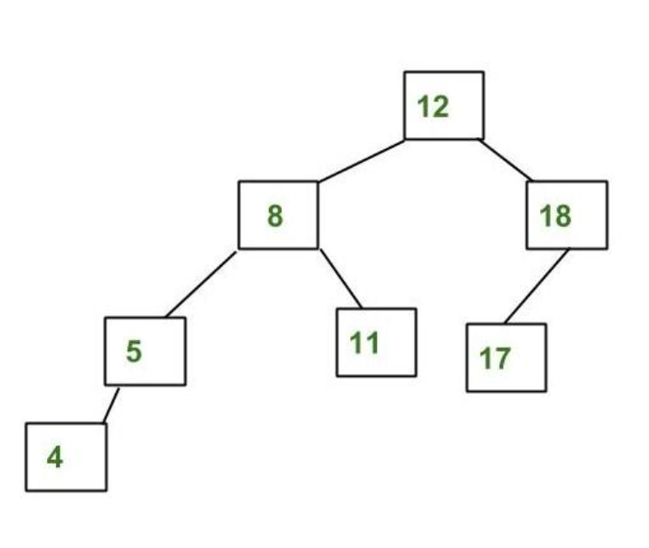

The above tree is AVL because the differences between the heights of left and right subtrees for every node are less than or equal to 1.

## Example of a Tree that is NOT an AVL Tree:

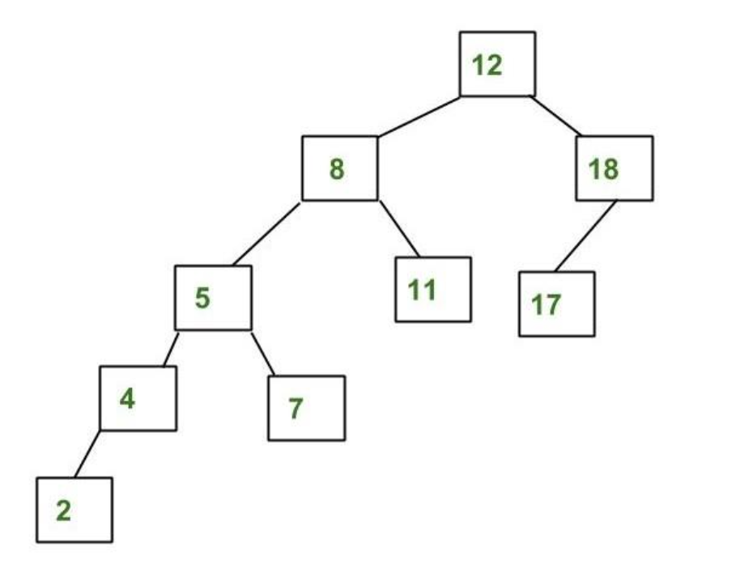

The above tree is not AVL because the differences between the heights of the left and right subtrees for 8 and 12 are greater than 1.

## Why AVL Trees?

*Most of the BST operations (e.g., search, max, min, insert, delete.. etc) take****O(h)****time where****h****is the height of the BST. The cost of these operations may become****O(n)****for a****skewed Binary tree****. If we make sure that the height of the tree remains****O(log(n))****after every insertion and deletion, then we can guarantee an upper bound of****O(log(n))****for all these operations. The height of an AVL tree is always****O(log(n))****where****n****is the number of nodes in the tree.*

### Rotations in AVL Trees:

*Rotations are the most important part of the working of the AVL tree. They are responsible for maintaining the balance in the AVL tree. There are 4 types of rotations based on the 4 possible cases:*

1. *Right Rotation (RR)*
2. *Left Rotation (LL)*
3. *Left-Right Rotation (LR)*
4. *Right-Left Rotation (RL)*

#### Right Rotation (RR)

*The Right Rotation (RR) is applied in an AVL tree when a node becomes unbalanced due to an insertion into the right subtree of its right child, leading to a Left Imbalance. To correct this imbalance, the unbalanced node is rotated 90° to the right (clockwise) along the top edge connected to its parent.*

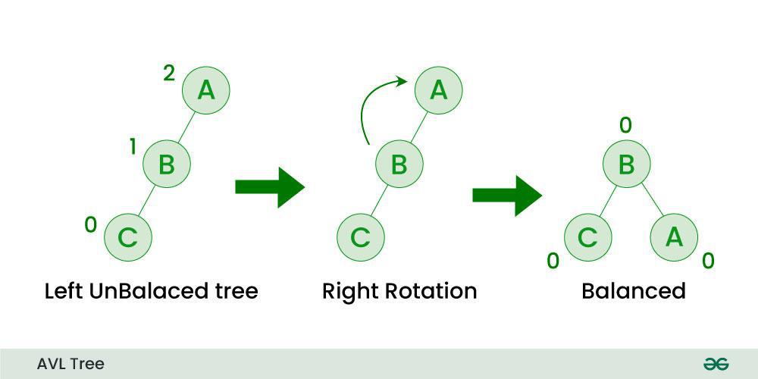

|  |
| --- |
|  |

#### Left Rotation (LL)

*The Left Rotation (LL) is used to balance a node that becomes unbalanced due to an insertion into the left subtree of its left child, also resulting in a Left Imbalance. The solution is to rotate the unbalanced node 90° to the left (anti-clockwise) along the top edge connected to its parent.*

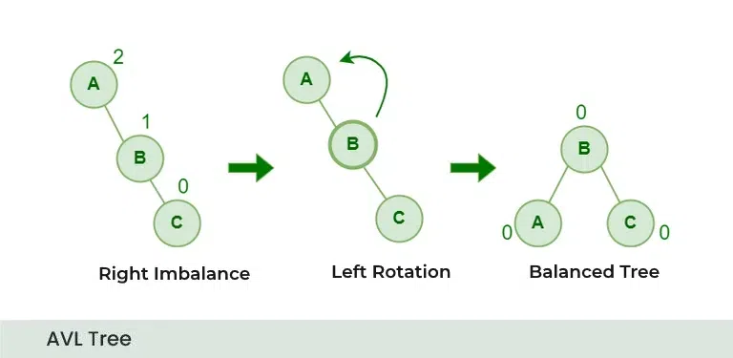

|  |
| --- |
|  |

#### Left-Right Rotation (LR)

*The Left-Right Rotation (LR) is necessary when the left child of a node is right-heavy, creating a double imbalance. This situation is resolved by performing a left rotation on the left child, followed by a right rotation on the original node.*



#### Right-Left Rotation (RL)

*The Right-Left Rotation (RL) is used when the right child of a node is left-heavy. This imbalance is corrected by performing a right rotation on the right child, followed by a left rotation on the original node.*

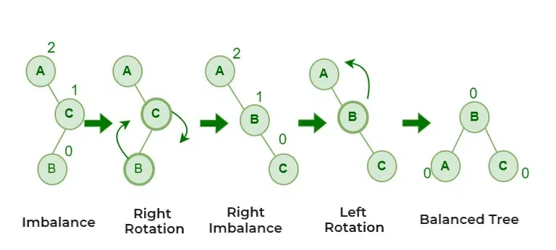

## Insertion in AVL Tree:

To make sure that the given tree remains AVL after every insertion, we must augment the standard BST insert operation to perform some re-balancing. Following are two basic operations that can be performed to balance a BST without violating the BST property (keys(left) < key(root) < keys(right)).

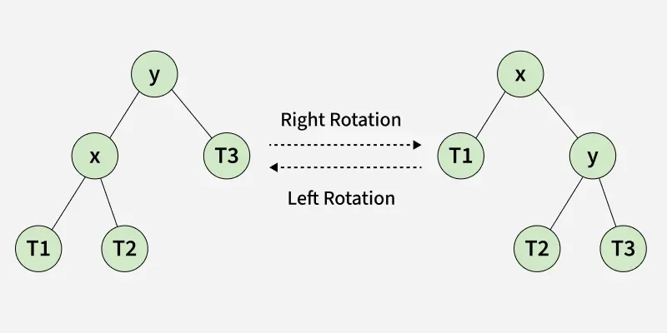

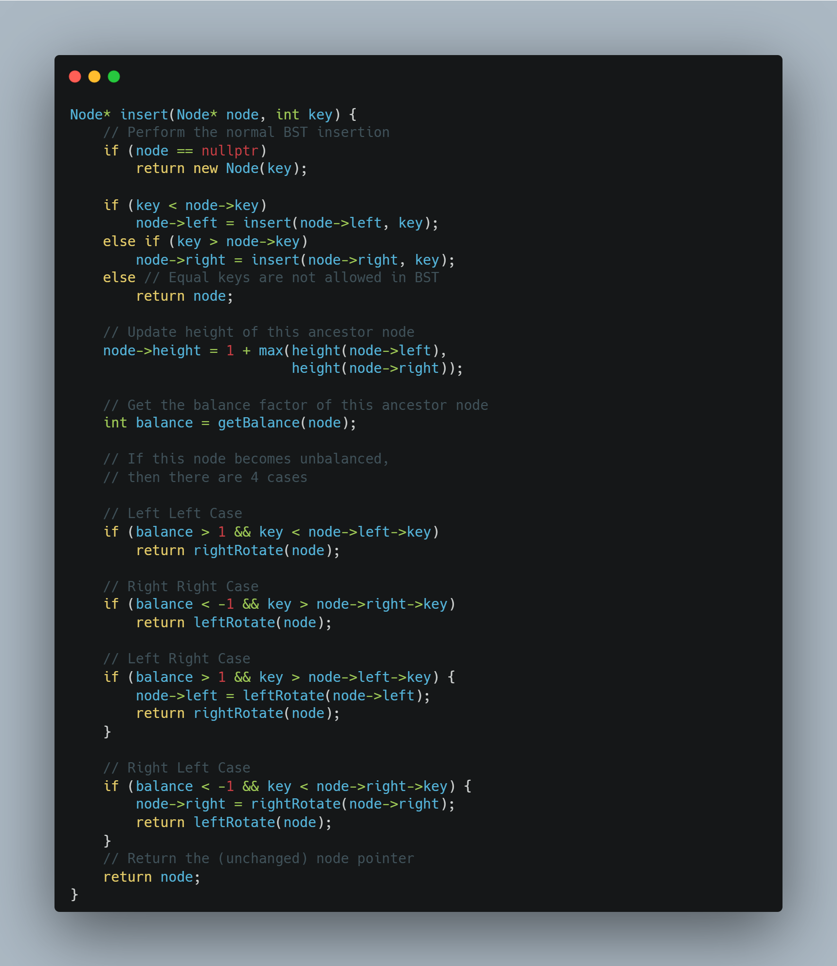

### Illustration of Insertion at AVL Tree

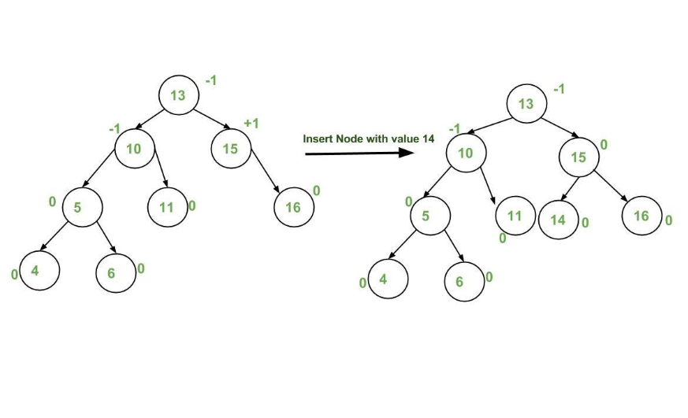

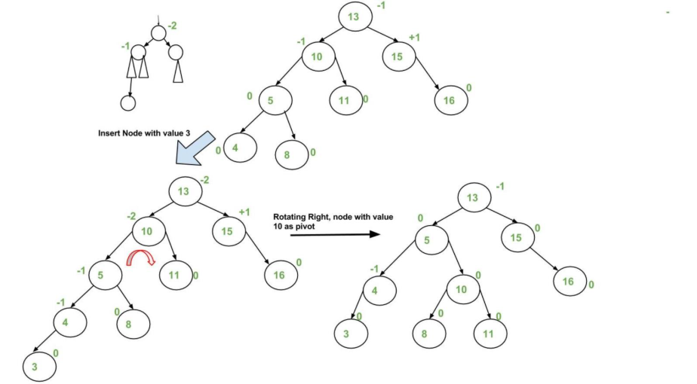

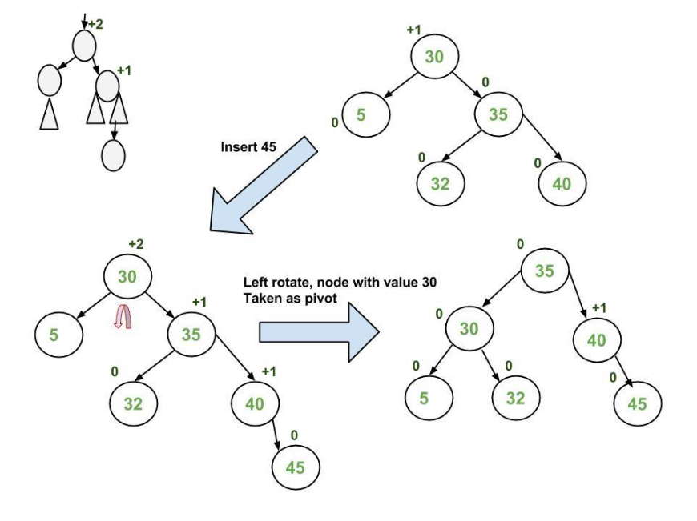

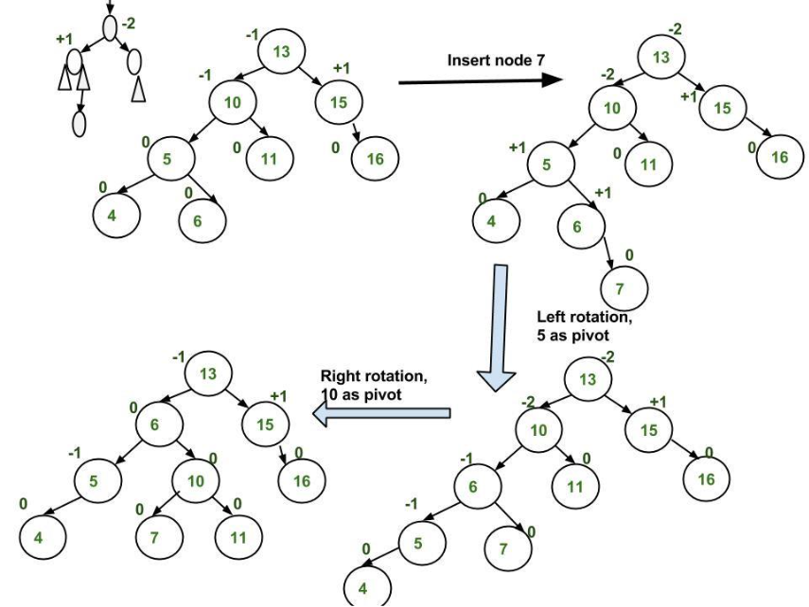

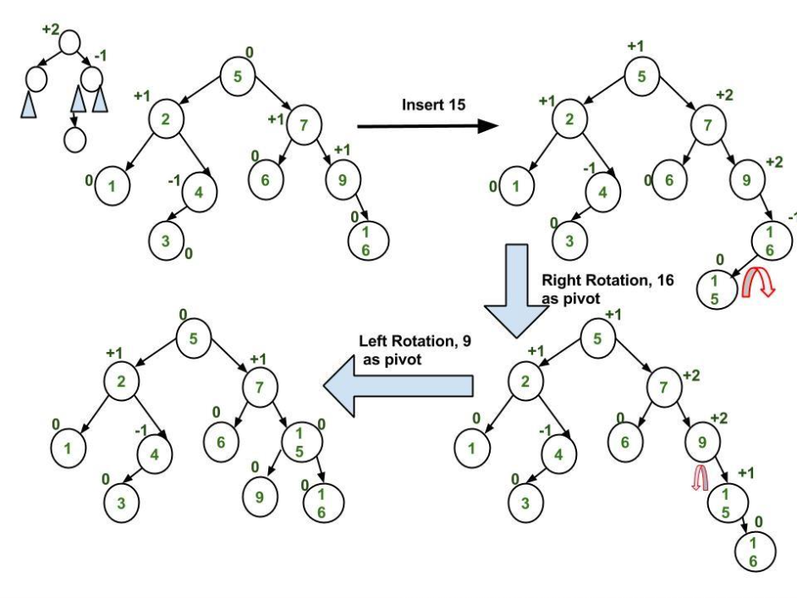

## Deletion in AVL Tree:

Deletion in an AVL tree involves removing a node and then ensuring the tree remains balanced. After deleting a node, the balance factor of each node is checked, and rotations are performed if necessary to maintain the AVL property.

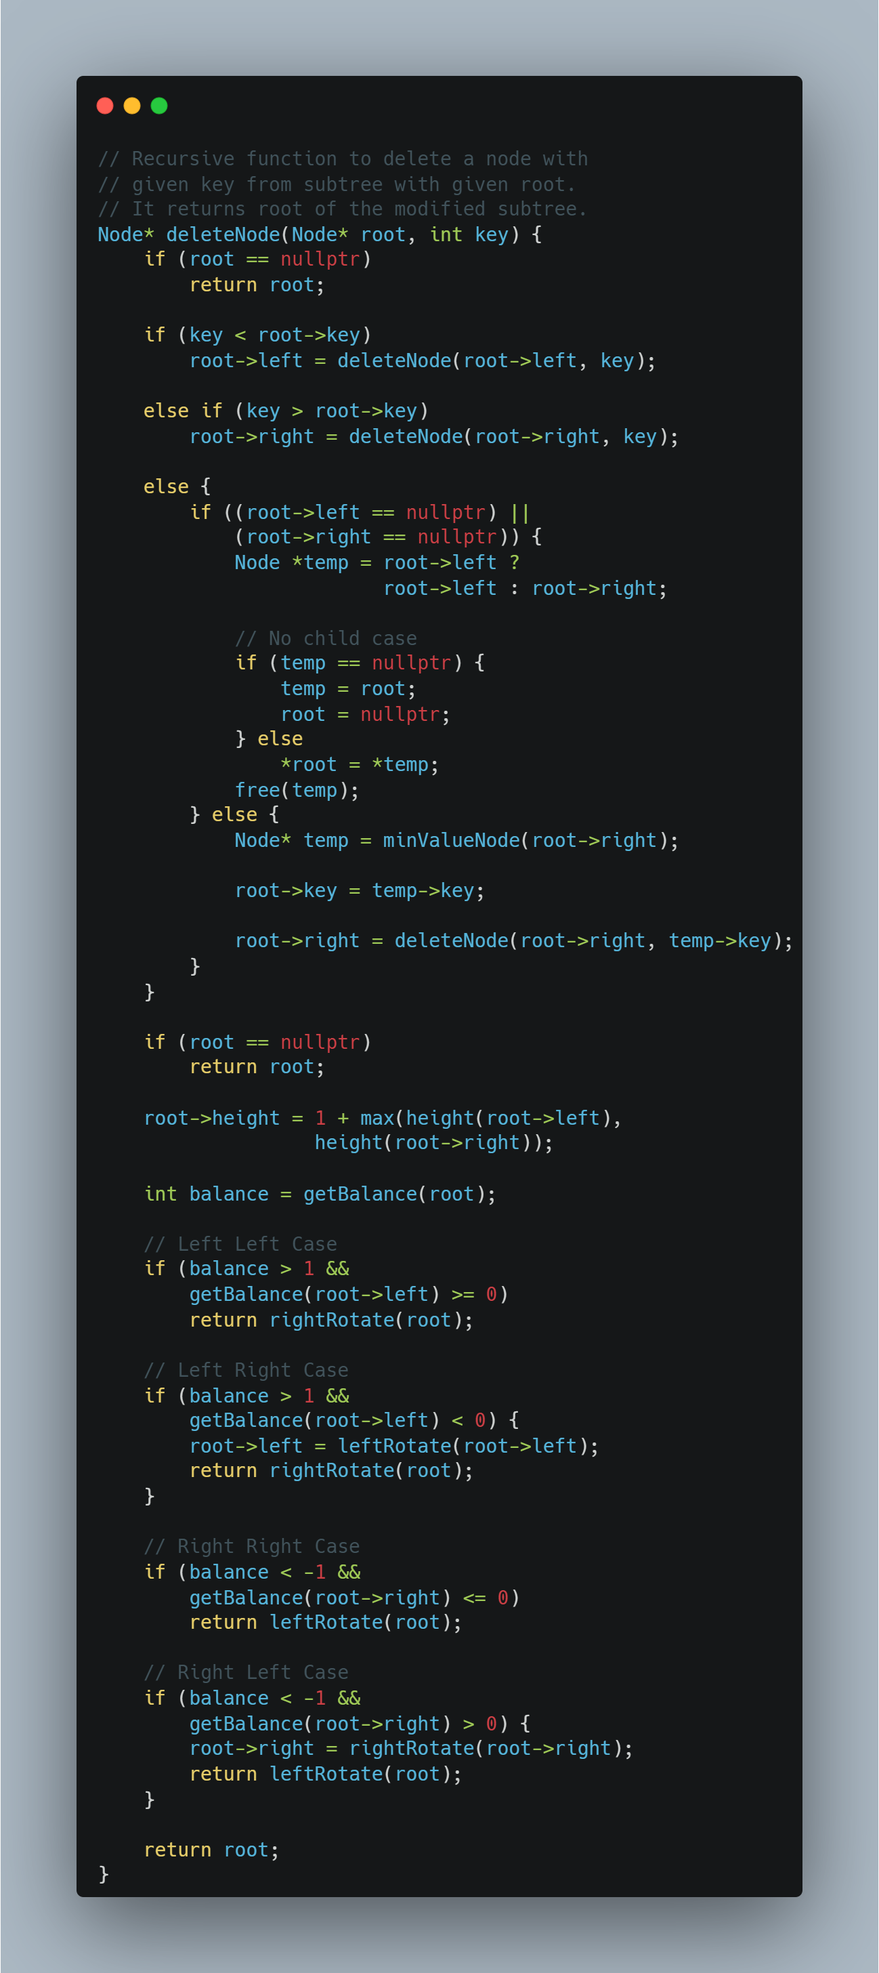

## Searching in AVL Tree:

Searching in an AVL tree is similar to searching in a binary search tree (BST). Since AVL trees are balanced, searching is efficient with a time complexity of O(log n).

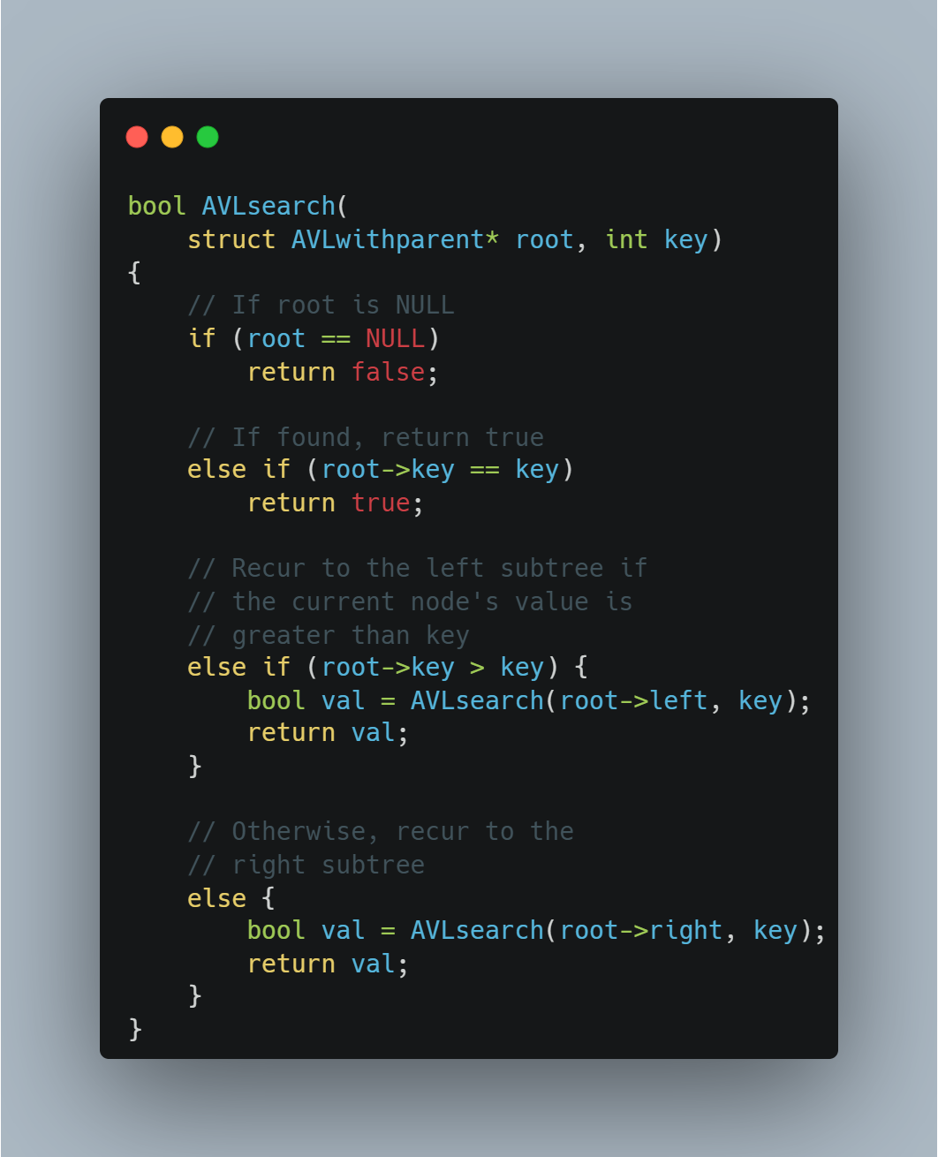

# **LAB TASKS**